Implement Of the TSTR

1. Library Installation and Drive Mounting
You began with !pip install sdv to ensure that the SDV (Synthetic Data Vault) library was available in your Google Colab environment since SDV is essential for generating high quality synthetic data for data-driven model evaluation. By importing pandas and mounting Google Drive with drive.mount(), to ensured smooth data access and manipulation and made datasets stored in Google Drive accessible.
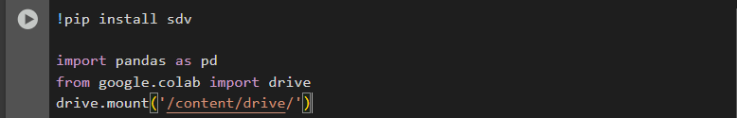

2. Data Loading and Cleaning
Loaded the real health dataset using pd.read_csv() directly from Google Drive. Because machine learning models can be sensitive to inconsistencies, immediately cleaned the dataset by dropping duplicates and removing rows with missing values using drop_duplicates() and dropna(). This makes sure that both real data and any synthetic data generated later are reliable and do not have artifacts that could bias your results or cause errors when training models.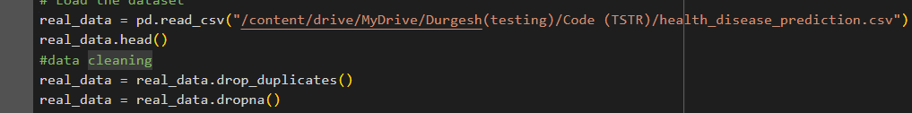

3. Label Encoding Categorical Data
To use the dataset with machine learning algorithms, needs all input features and the target column to be numeric. Many ML algorithms, including KNN and tree-based models, cannot handle string labels. Therefore, I used LabelEncoder from sklearn to convert the Disease column from text to integers, making it compatible with the ML models planned to use.
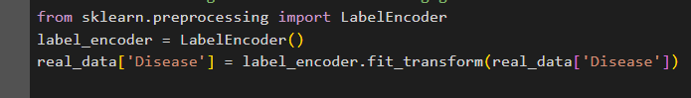
\

4. Metadata Detection for SDV
Before generating synthetic data, I have to explain to SDV the structure of dataset. By using Metadata.detect_from_dataframe, allow SDV to automatically infer the data types and relationships between the columns. This step is crucial because SDV’s generative models require clear schema information to accurately mimic the data’s structure and constraints, which helps in generating realistic synthetic samples.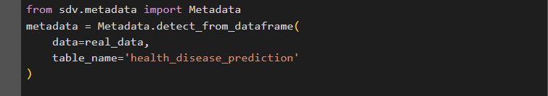

5. Synthetic Data Generation using TVAE
Choosing the TVAESynthesizer, a model based on neural network architectures, to generate synthetic data. This choice is motivated by TVAE’s ability to preserve complex relationships between columns better than simple random sampling approaches. Training on the cleaned real data allowed the TVAE model to learn the with-in data distributions, and sampling 1500 synthetic records created a dataset large enough for robust testing and evaluation.

6. Feature Splitting
To prepare for machine learning, I am splitting both the real and synthetic datasets into features (X) and the label (y). Dropping the target column into a separate variable is a standard step because ML algorithms are generally supervised they learn to predict y (target) from X (input features).
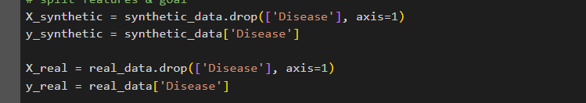

7. Train-Test Splitting
I have applied train_test_split to split your datasets into training and testing subsets. Splitting is critical to measure how well a model generalizes: by training on one part of the data and testing on an unseen holdout. This also mimics real-world scenarios where models are deployed on new, unseen data, boosting the credibility of evaluation.
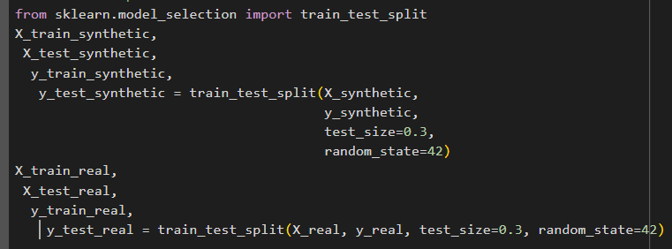

8. Feature Scaling
Since KNN (and many ML algorithms) is sensitive to the scale of input features, I have normalized the features using StandardScaler (and experimented with MinMaxScaler). This transformation ensures that all features contribute equally to the distance-based calculations in KNN, rather than being dominated by variables with large numeric ranges.
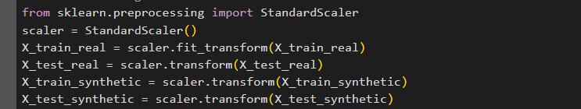

9. KNN Training on Synthetic, Testing on Real (TSTR)
The core experiment was to train a KNN classifier only on synthetic data and test it on real data. This follows the TSTR (Train Synthetic, Test Real) paradigm, which is a powerful way of assessing whether the synthetic data captures real-world distributions well enough that a model can generalize from synthetic to real samples. If performance is strong, it means the synthetic data is of high fidelity and utility.
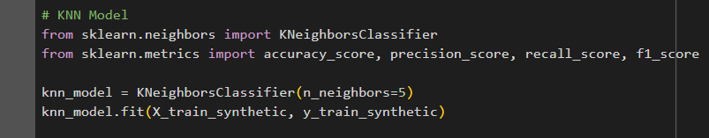
Output:-
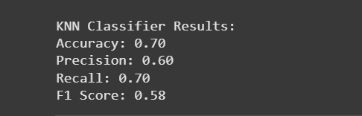

10. Classification Performance Evaluation
I used metrics such as accuracy, precision, recall, and F1 score. These metrics cover different performance perspectives: accuracy for overall correctness, precision for positive predictive value, recall for sensitivity, and F1 for a balance of the two. This comprehensive evaluation is important because it reveals potential weaknesses such a model that is accurate but fails to recall certain classes), especially in healthcare where errors can be costly.
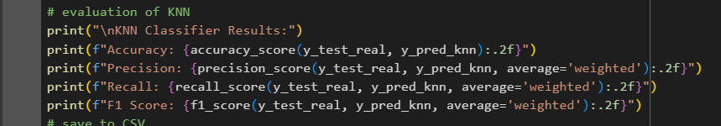

XGboost classifier & analysed its accuracy on real test data
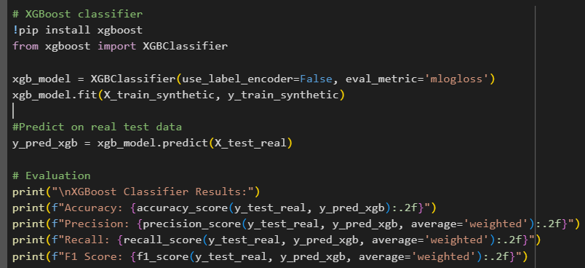

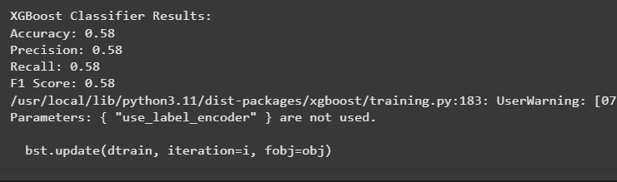

11. Visualization: Confusion Matrix and Metric Bar Plot
Visualization is essential for effective communication of ML results. The confusion matrix illustrates precisely how the model performs across different disease categories, making it easier to see where it struggles. The metrics bar plot succinctly compares performance metrics, allowing quick scanning and highlighting tradeoffs between accuracy, precision, recall, and F1.
import matplotlib.pyplot as plt
import seaborn as sns
from sklearn.metrics import confusion_matrix, ConfusionMatrixDisplay, classification_report
#Confusion Matrix Plot
cm = confusion_matrix(y_test_real, y_pred_knn)
plt.figure(figsize=(6, 5))
sns.heatmap(cm, annot=True, fmt='d', cmap='Blues', cbar=False,
xticklabels=label_encoder.classes_,
yticklabels=label_encoder.classes_)
plt.xlabel('Predicted Label')
plt.ylabel('True Label')
plt.title('Confusion Matrix (KNN on Synthetic → Tested on Real)')
plt.tight_layout()
plt.show()
#bar plot of evaluation matrix
accuracy = accuracy_score(y_test_real, y_pred_knn)
precision = precision_score(y_test_real, y_pred_knn, average='weighted')
recall = recall_score(y_test_real, y_pred_knn, average='weighted')
f1 = f1_score(y_test_real, y_pred_knn, average='weighted')

metrics = [accuracy, precision, recall, f1]
metric_names = ['Accuracy', 'Precision', 'Recall', 'F1 Score']

plt.figure(figsize=(8, 5))
sns.barplot(x=metric_names, y=metrics, palette='Set2')
plt.ylim(0, 1)
plt.title('KNN Performance Metrics')
for i, val in enumerate(metrics):
plt.text(i, val + 0.02, f"{val:.2f}", ha='center')
plt.tight_layout()
plt.show()

Output:
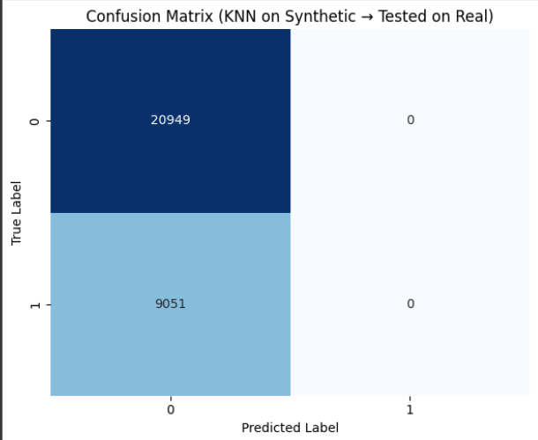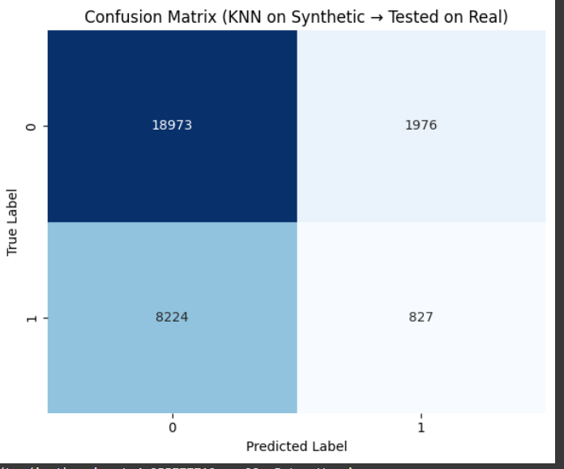

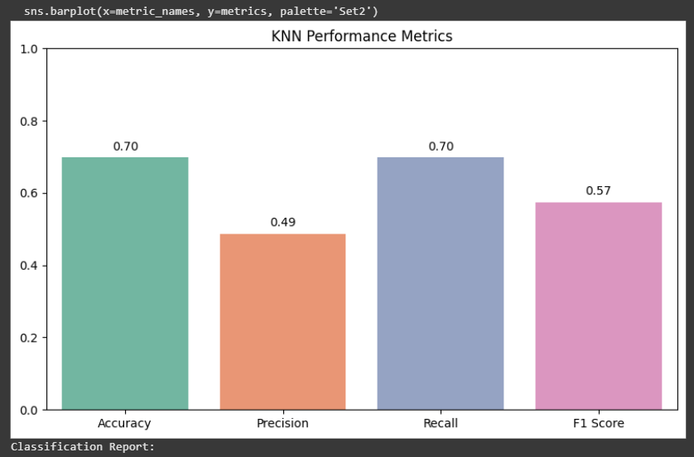
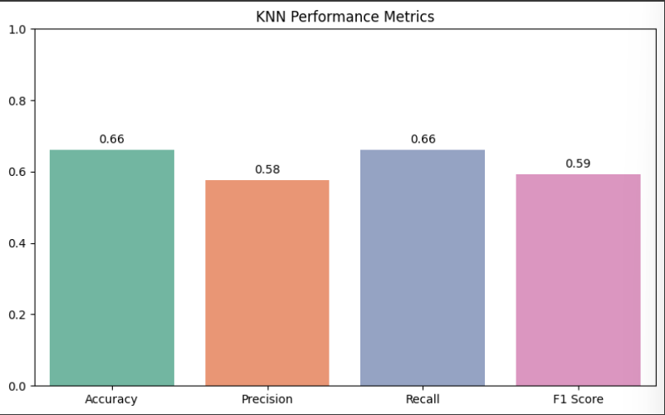

12. Final Hyperparameter Sweep with MinMaxScaler
Finally, I repeated the KNN experiment with MinMaxScaler and visualized KNN’s performance across different k values to identify the best number of neighbors. This sweep helps identify robust patterns and the most effective settings for use-case, ensuring that the conclusions drawn are not artefacts of a poorly-chosen hyperparameter.

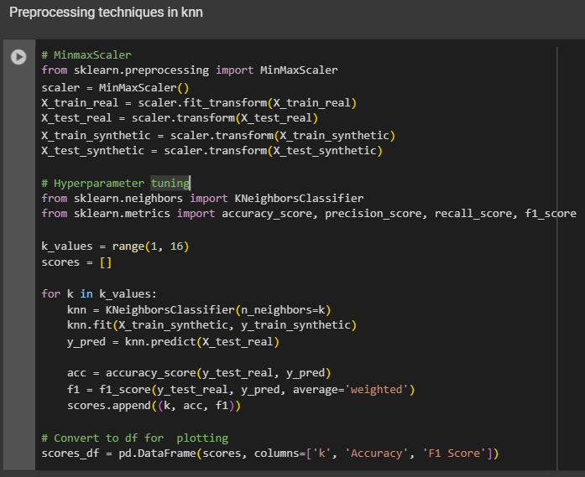

13. Comparison with Gradient Boosting
I also trained a more advanced model (Gradient Boosting) on synthetic data and tested it on real data. The goal here was to check whether conclusions about the quality of synthetic data hold across different types of models: simple (KNN) and complex (ensemble trees). Gradient

Boosting can often detect subtler patterns which KNN might miss, using it validates that the synthetic data's utility is not specific to one model.

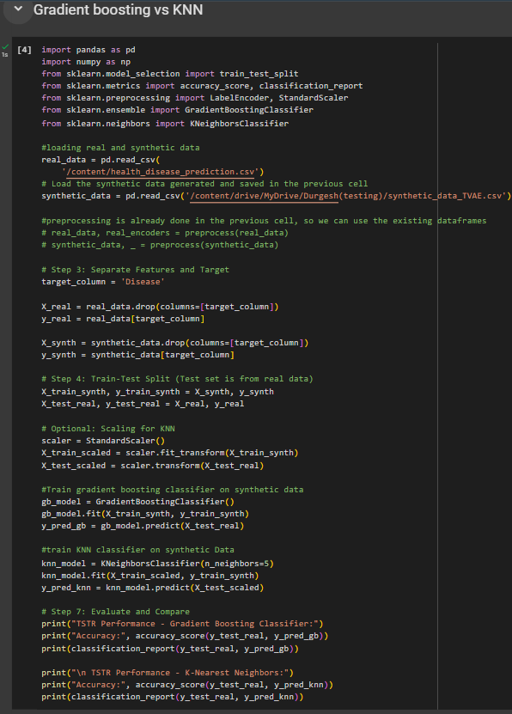
Output:-
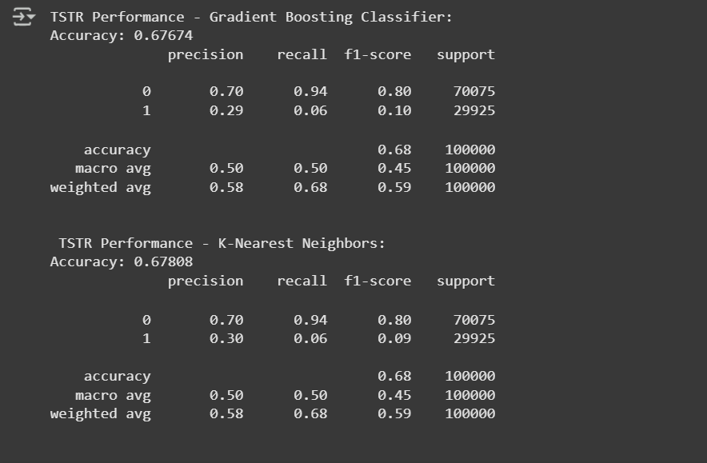

14.KNN Hyperparameter Tuning
To optimize your KNN performance, I have systematically varied the number of neighbors (k) and the distance metric. This grid search approach is a standard ML practice to discover the most suitable hyperparameters for a given scenario, as KNN’s performance is highly sensitive to these choices
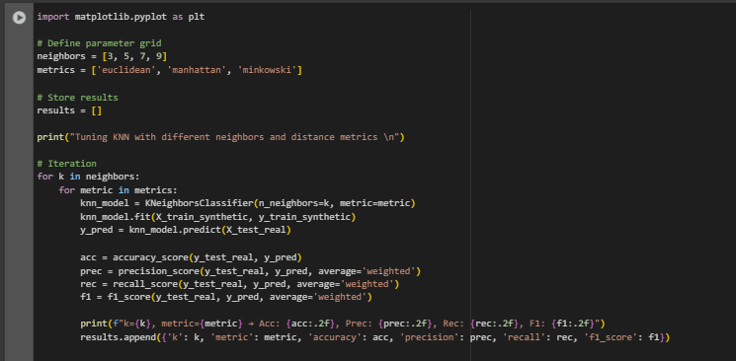.

15. Baseline Evaluation: KNN Model Trained and Tested on Real Data (Real-to-Real)
To establish a solid benchmark for comparison with TSTR results, I have done Real to Real evaluation of the KNN classifier. In this, the model was both trained and tested on real-world health disease prediction data using a train test split. Before training, the data was cleaned by removing duplicates and missing values, followed by label encoding of the categorical target feature such as Disease. Numerical features were scaled using StandardScaler to ensure fair distance-based computations in the KNN model.
I have trained the KNN classifier using default hyperparameters ( n_neighbors=5) and evaluated its performance on the held-out real test data using standard metrics including Accuracy, Precision, Recall, and F1 score

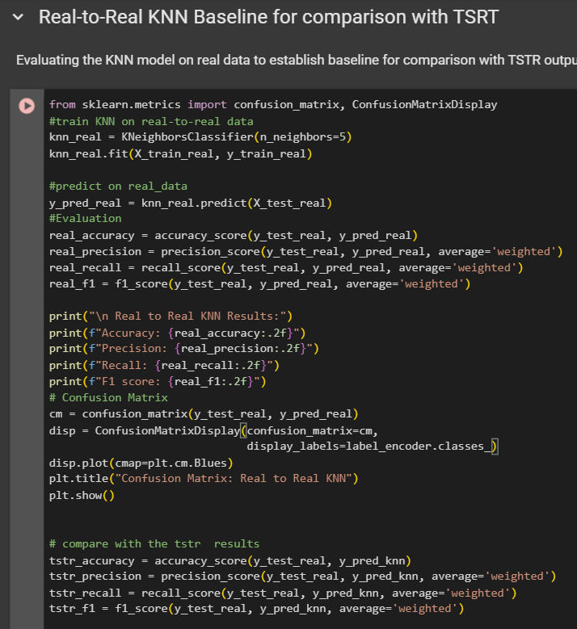

16. Error Analysis

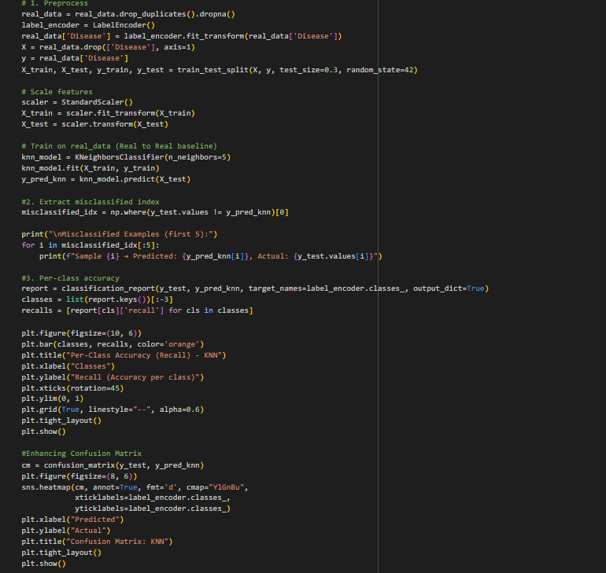
Output:
